Self Evaluation 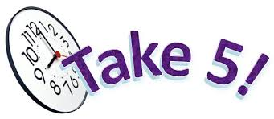

Give yourself a grade from 1-5 for each of these criteria

Name_____________________

 I spoke clearly and could be heard by everyone

 I spoke with enthusiasm and tone

 I had prepared my talk well

 I did not speak too fast

 I paused in places that needed special emphasis

 I looked at my audience often

 I had a visual aide that linked well to my talk

 I used the visual aide as part of my talk

What do you think went well with your presentation?

______________________________________________________________________________________________________________________________________________________________________________________________________________________________________________________________________________________________________________________________________________________________

What do you think you need to work on to make your next presentation better?

______________________________________________________________________________________________________________________________________________________________________________________________________________________________________________________________________________________________________________________________________________________________